How To Use Program

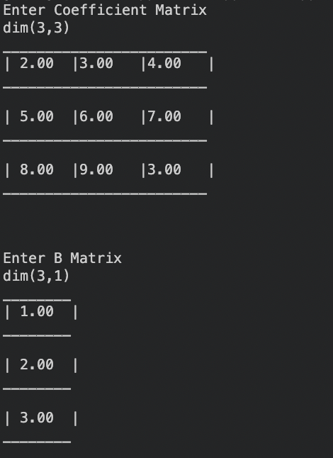

Result of Program

